American Language, Culture & Leadership Summer 2018
Sunday | Monday | Tuesday | Wednesday | Thursday | Friday | Saturday
 | July 16 | July 17 | July 18 | July 19 | July 20 | July 21
Arrive at Albany International Airport  (Airport Code: ALB)  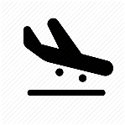 | Orientation  and  Campus Tour  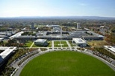 | 10:00 am – 12:00 pm  Language & Culture Classes  12:00 pm – 1:30 pm  Welcome Lunch  1:30 pm – 3:30 pm  Leadership Classes | 10:00 am – 12:00 pm  Language & Culture Classes  12:00 pm – 1:30 pm  Lunch Break  1:30 pm – 4:00 pm  NY State Capitol Tour  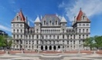 | 10:00 am – 12:00 pm  Language & Culture Classes  12:00 pm – 1:30 pm  Lunch Break  1:30 pm – 3:30 pm  Leadership Classes | 10:00 am – 12:00 pm  Language & Culture Classes  12:00 pm – 1:30 pm  Lunch Break  1:30 pm – 3:30 pm  Leadership Classes | 7:00 am – 9:00 pm  Boston
July 22 | July 23 | July 24 | July 25 | July 26 | July 27 | July 28
Free Time -  Explore on Your Own! | 10:00 am – 12:00 pm  Language & Culture Classes  12:00 pm – 1:30 pm  Lunch Break  1:30 pm – 3:00 pm  Leadership Workshop Series | 10:00 am – 12:00 pm  Language & Culture Classes  12:00 pm – 1:30 pm  Lunch Break  1:30 pm – 3:30 pm  Leadership Classes | 10:00 am – 12:00 pm  Language & Culture Classes  12:00 pm – 1:30 pm  Lunch Break  1:30 pm – 4:00 pm  New York State Museum  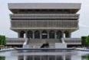 | 10:00 am – 12:00 pm  Language & Culture Classes  12:00 pm – 1:30 pm  Lunch Break  1:30 pm – 3:30 pm  Leadership Classes | 10:00 am – 12:00 pm  Language & Culture Classes  12:00 pm – 1:30 pm  Lunch Break  1:30 pm – 3:30 pm  Leadership Classes | 9:00 am – 5:00 pm  Norman Rockwell Museum & Lee Premium Outlets Shopping  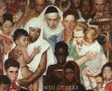
July 29 | July 30 | July 31 | August 1 | August 2 | August 3 | August 4
Free Time -  Explore on Your Own! | 10:00 am – 12:00 pm  Language & Culture Classes  12:00 pm – 1:30 pm  Lunch Break  1:30 pm – 3:00 pm  Leadership Workshop Series | 10:00 am – 12:00 pm  Language & Culture Classes  12:00 pm – 1:30 pm  Lunch Break  1:30 pm – 3:30 pm  Leadership Classes | 10:00 am – 12:00 pm  Language & Culture Classes  12:00 pm – 1:30 pm  Lunch Break  1:30 pm – 4:00 pm  UAlbany Undergraduate Admissions Seminar  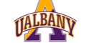 | 10:00 am – 12:00 pm  Language & Culture Classes  12:00 pm – 1:30 pm  Lunch Break  1:30 pm – 3:30 pm  Leadership Classes | 10:00 am – 12:00 pm  Language & Culture Classes  12:00 pm – 1:30 pm  Lunch Break  1:30 pm – 3:30 pm  Leadership Classes | 7:00 am – 9:00 pm  New York City  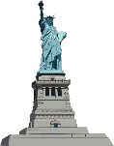
August 5 | August 6 | August 7 | August 8 | August 9 | August 10 | August 11
Free Time -  Explore on Your Own! | 10:00 am – 12:00 pm  Language & Culture Classes  12:00 pm – 1:30 pm  Lunch Break  1:30 pm – 3:00 pm  Leadership Workshop Series | 10:00 am – 12:00 pm  Language & Culture Classes  12:00 pm – 1:30 pm  Lunch Break  1:30 pm – 3:30 pm  Leadership Classes | 10:00 am – 12:00 pm  Language & Culture Classes  12:00 pm – 12:30 pm  Lunch Break  12:30 pm – 3:00 pm  Hudson River Cruise  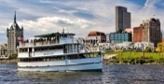 | 10:00 am – 12:00 pm  Language & Culture Classes  12:00 pm – 1:30 pm  Lunch Break  1:30 pm – 3:30 pm  Leadership Classes | 12:00 pm – 2:00 pm  Farewell Lunch  and Graduation  Congratulations! | Depart Albany International Airport  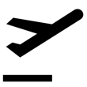  (Airport Code: ALB)

