Business English and Leadership Studies
3-Week Program: July 23 – August 10, 2018
4-Week Program: July 16 – August 10, 2018
Intensive English Language Program
University at Albany

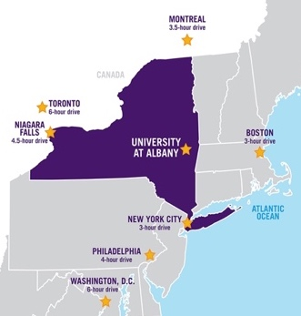
Study English in New York State – The Ideal Location
New York is world-famous for culture, the arts, media, business, history, entertainment, fashion, international diplomacy, theater and world-class universities. New York is also the ideal location for Olympic skiing, beaches, lakes, mountains and rivers.
Many landmarks are well-known and New York hosts several of the world’s 10 most-visited attractions: Niagara Falls, Central Park, Times Square and Grand Central Station. Visiting the Statue of Liberty and Wall Street are other must-do experiences.
Housing*
Students have two housing options on the UAlbany campus. On-campus dormitories or on-campus apartments. On-campus dormitories require a meal plan. On-campus apartments feature full kitchens. All housing includes the following amenities: fitness center, wireless Internet and laundry services.
*Housing depends upon availability.

Transportation
The University at Albany is conveniently located 10 minutes from Albany International Airport. Popular connecting flights arrive daily from Chicago, Detroit, Philadelphia, Atlanta and Newark. Students ride UAlbany buses and City of Albany buses for free. Taxis, Lyft, and Uber also provide convenient ways to travel around the city. Amtrak trains, Greyhound buses and Adirondack Trailways buses also provide easy access to Boston, New York City and many other popular destinations.

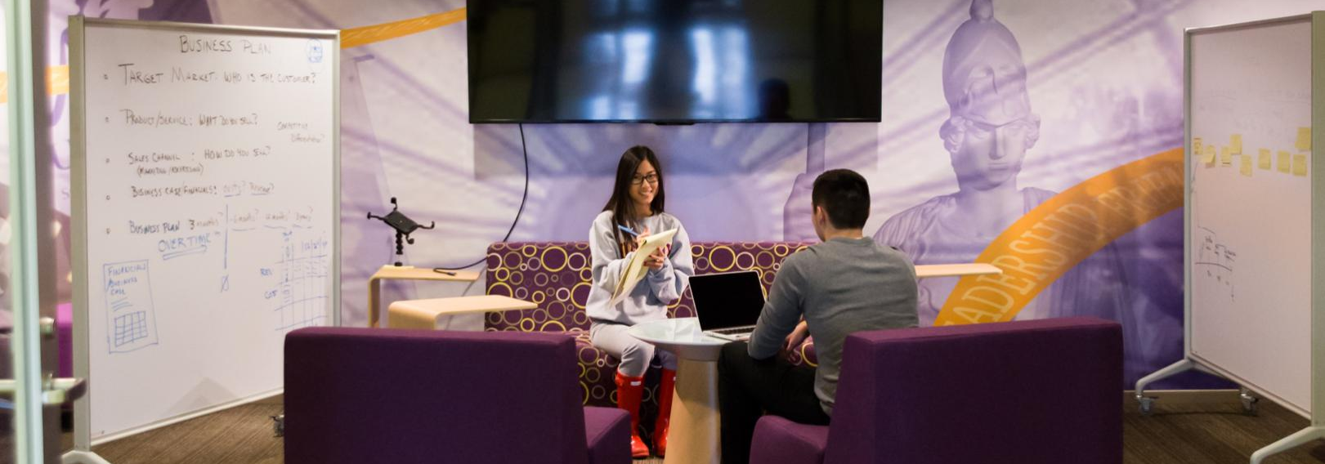
Business English and Leadership Studies
Students learn the vocabulary needed to lead in a variety of situations – leading an organization, leading a team, leading employees. Students will improve their understanding of business and leadership concepts in the workplace. They will also increase their own self-awareness of their abilities as leaders.
Students will role-play group discussions and networking, analyze different possible leadership styles, and make decisions that incorporate different levels of thinking – how decisions affect individuals, organizations, and the world. They will gain exposure to the challenges that arise for leaders in today’s diverse, global organizations.
Classroom Topics

- Key Concepts of Leadership
- Managing People
- Getting and Giving Direction
- Creating and Managing Teams
- Getting and Giving Feedback
- Leadership Styles
- Representing a Team
- Cross-Cultural Differences
- Leading International Teams
- Problem-Solving

Special Presentations and Workshops will also be offered with leading experts in their field.

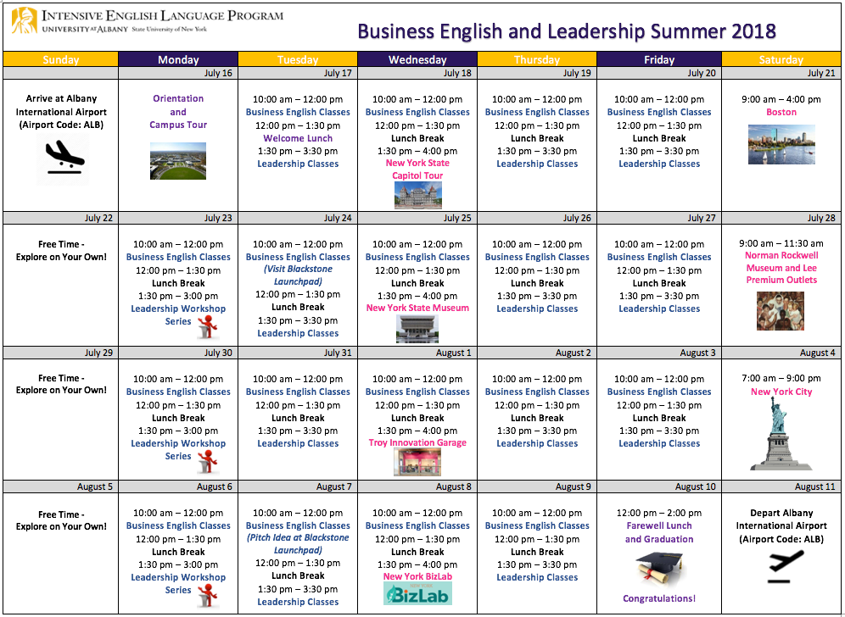
Classes and activities are subject to change.

